|  |
| --- |
| **SOUTHERN CROSS UNIVERSITY** |

**ASSIGNMENT COVER SHEET**

For use with online submission of assignments

Please complete all of the following details and then make this sheet the **first page of each file of your assignment – do not send it as a separate document.**

Your assignments must be submitted as either **Word documents, text documents with .rtf extension or as .pdf documents**. If you wish tosubmit in any other file format please discuss this with your lecturer well before theassignment submission date.

|  |  |
| --- | --- |
| Student Name: | Jiawen Bu_________________________ |
| Student ID No.: | 23811557_________________________ |
| Unit Name: | **Developing the User Experience** |
| Unit Code: | **PROG2001** |
| Tutor’s name: | **Viettrung Luong** ____________________________ |
| Assignment No.: | **Assignment 3, Design Documentation** |
| Assignment Title: | **Documentation** |
| Due date: | 2022.4.20____________________________ |
| Date submitted: | 2022.4.20____________________ |

Declaration:

*I have read and understand the Rules Relating to Awards (*[*Rule 3 Section 18 – Academic Misconduct Including Plagiarism*](http://policies.scu.edu.au/view.current.php?id=00140#s18)*) as contained in the SCU Policy Library. I understand the penalties that apply for plagiarism and agree to be bound by these rules. The work I am submitting electronically is entirely my own work.*

|  |  |
| --- | --- |
| Signed:  (please type your name) | Type your name here_____Jiawen Bu_______________________ |
| Date: | And put the date here______2022.4.20______________________ |

**[Environmentalist]**

**Design Documentation**

By [Alice Team]

Jiawen BU

Table of Contents

Introduction 1

GitHub link（Ass3 link） 1

Background 1

Key Features 2

Theme 2

Storyboards 3

Media 11

Menu: 15

Picture: 15

Color 15

Music 15

Button 15

Font 15

UI 15

My Scene 16

Picture: 16

Color 16

Music 16

In terms of music, I adopted a mysterious and tense music, creating a "rescue" feeling, so that users have a feeling of personal experience at the scene. At the same time, this kind of music can mobilize the excitement of the user, so they keep the game freshness. At the same time, the button will give the user a feedback to the user, so that they will not discomfort because they don't know if they click. Optimize the user experience. 16

Button 16

Font 16

UI 16

Group character assignment 17

UI discussion notes 17

GitHub modification record 23

ASS2_Link and comment 24

# Introduction

This is an eco-themed game. Our group hopes to use these little games to reflect some of the current situation and make everyone aware of the importance of environmental protection.

Our group's menu is more warm in terms of color. Urban assets were inserted during the production process, with trash cans and Coke cans representing the theme of "green".

Also placed in the city is a little girl representing the three of us. Although she may not be the protagonist of our subsequent scenes, she still represents the three of us girls.

Of course, there are some buttons in the menu. Pressing these buttons will make a sound to remind the user. And when the mouse is moved, the button will have some color changes, all for a better user experience.

Telling an environmental rescue story in my own set. A boy was caught by the bad guys in order to stop the workers from cutting down trees. "I" must collect enough gold coins in the forest to exchange for the opportunity to cross the bridge.

Then rescue my partner and start the next environmental journey. In my scene, you can use the mouse to control the vision, and use the keyboard to control the character to move, so that the character can collect gold coins. Every time you collect a gold coin, there will be a display in the upper right corner, and there will also be a countdown in the upper left corner.

If you don't collect enough coins within the time limit, the game will fail. When ten gold coins are collected, a prompt window will pop up to guide the user to rescue their partner through the bridge.

# GitHub link（Ass3 link）

https://github.com/JiawenBu/Alice-Team/commits/main

# Background

*The background of the whole game is under the theme of "environmental protection", which tells the stories of environmental protection in three different locations. In my scene, I mainly talk about "tree environmental protection". In this scene, most of the assets are trees, stones, wooden houses and so on. The little girl's companion was caught for preventing the bad guys from cutting down the tree,*

*The little girl picks up gold coins in exchange for the chance to cross the bridge to rescue her companions. The background of the whole picture is relatively simple and fresh, highlighting typical representatives such as trees. Accompanied by background music to create a tense atmosphere.*

# Key Features

*First, have good UI design. In the scene, the size of the screen is moderate, which will not make the user feel uncomfortable. And set up a start page, on which you can view "Help", in order to understand what the game is going to do, without confusing users. There are also two end pages designed. If your rescue is successful, "Successful" will pop up, if it fails, "Rescue Failed" will pop up. In the game scene, there is a time countdown in the upper left corner, so that the user can clearly recognize the remaining time, and there is also a hint of the number of gold coins in the upper right corner to help users with technology. At the same time, when 10 gold coins are picked up, a prompt window will pop up to inform the next action, so as to avoid users being confused because they don’t know what to do. When the user approaches the boy through the bridge, a prompt window will pop up to improve how the user can rescue the boy. In this way, the user is guided through the operation step by step, without feeling overwhelmed while gaining the gaming experience. At the same time, on the start and end pages, because the background is a bit fancy, I also added "panel" to slightly separate the prompt word from the background, so that the user can see the prompt word clearly. Of course, in all pages I use buttons, when the mouse rolls over the button, the button changes color, and when the mouse clicks on the button, the button changes to another different color, in this way, the user's actions are distinguished. The contrast between the changed color and before the change is more obvious, which gives the user a stronger visual impact and a better user experience, and allows the user to understand the game faster. At the same time, there is background music in the game, so I didn't design the button sound when the game is in progress, I think it can be clearer. I have added button beeps on both the start and end pages. These UI designs are very important, which can allow users to master the game faster, improve the user's user experience, and attract more users.*

*Second, the game has good animations and backgrounds. The style of the whole game is very fresh and not depressing. Tall trees, scattered stones, and exquisite wooden houses make users feel very comfortable. And all the animations are not too garish, and the character movement is also very coordinated, and it will not make the user feel very cluttered.*

*Then, the game has uncomplicated gameplay. Just control the mission to move, find gold coins and rescue the boy. There are no overly complicated game settings or gameplay, which makes it easy for users to understand, increases user experience, and allows users to relax during the game.*

*Finally, not huge file size. In my scene, I only downloaded and imported some of the assets I needed, others I didn't need to use, I didn't check them when importing. This saves disk space and speeds up the game. Saved a lot of hassle and burden.*

# Theme

The theme of our group this time is environmental protection. We hope that through these three games, we can show some of the status quo, or awaken people's hearts for environmental protection. Through this interesting method, the serious topic of "environmental protection" has become cheerful, and at the same time, through this easy-to-understand method, more people can be exposed to this aspect, awaken the heart of environmental protection, and participate in protecting environmental action.

# Storyboards

The following storyboards on the following pages provide a more detailed explanation of the planned product.

**Title**: Home Page **Frame ID**: *Home*

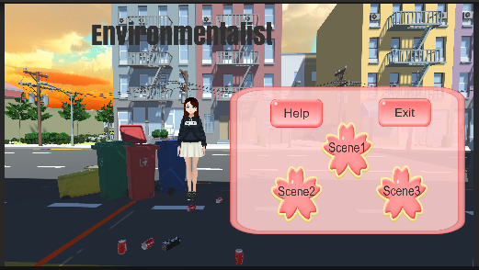**Dimensions:**

This scene will use the maximum

available to display in the window.

**Media Used:**

Background music: Of course, background music is also needed here. The background music selects mysterious and tense music, which conforms to the theme and background of the game, arouses users' interest in the game, echoes with other elements, and makes the overall atmosphere feel harmonious.

**Onclick**： There will be a sound feedback to ensure that the buttons successfully clicks the button and improve the user experience.

**Fonts：**Choose the simpler button. Because the background is more colorful, choose a lighter font to highlight the title and buttons. The font sizes are 20 and 80 respectively.

**Image:** This page is the main menu page of our group. After our discussion, we chose a warmer atmosphere for the background, and placed a little girl representing the three of us on it. Although she may not be the protagonist of our game, she is us representative. It also contains a trash can. Coke cans, etc., reflect our environmental theme. At the same time write our theme at the top. Clicking "Help" will pop up the "Help" prompt window, and clicking the three page buttons will enter different pages.

**Buttons:** The page provides "Help" and three ”scenes” buttons, and the text notes on the buttons are convenient for users to understand their functions (start the game or enter the help page).

**Background:** Choose a warmer environment as the background to accentuate a light atmosphere. It doesn't look messy when you add images or buttons. The page is concise and clear, fits the overall atmosphere, and brings a good user experience to users. And trash cans etc. fit the theme.

**Content:** This page is just a "Menu" page to guide users.

**Description (purpose / objectives):**

This page is just a "Menu" page to guide users. This page will give users a warm atmosphere of the game. The purpose is to guide users to start the game, choose to start the game or read help, better understand the game and arouse users' interest in the game.

**Animations:**

When the mouse is over or clicked on the button, the button will change to a different

color to enhance the user experience. And there will also be a button tone to remind

the user what to do.

**User Interactions Required:**

Users need to click the "Scene" button to start the game, or click "Help" to take good

knowledge of the game. When the mouse is over or clicked on the button, the button

will change to a different color to enhance the user experience. And there will also be a

button tone to remind the user what to do.

**User Feedback：**

Click the "Scene" button to start the game or click "Help" to take good

knowledge of the game. When the mouse is over or clicked on the button, the button

will change to a different color, and there will also be a button sound to give user

feedback.

Navigation / Links: The navigation bar will link to the three scenes and the help

window.

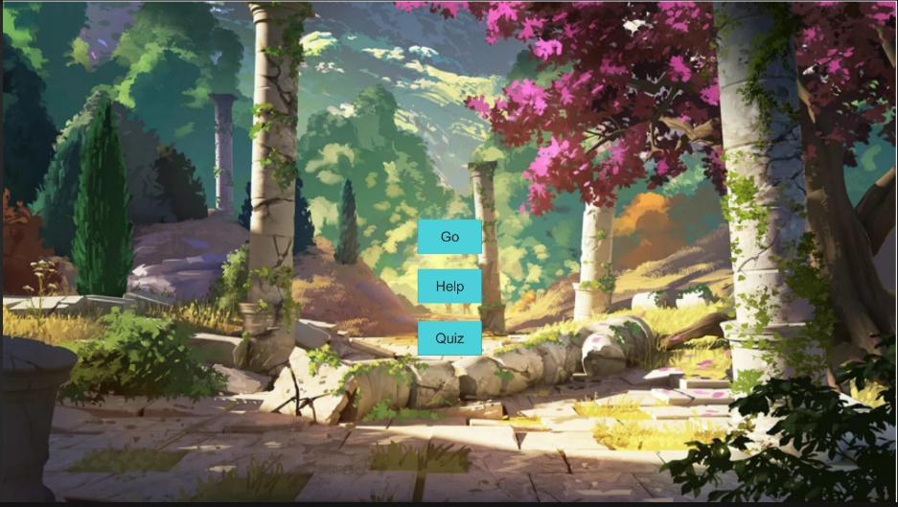**Title**: Begin Page **Frame ID**:Begin

**Dimensions:**

This scene will use the maximum

available to display in the window.

**Media Used:**

**Background music:** Since there are background music on the two pages before and after, and stay on this page for a short time, in order to prevent auditory confusion, no background music is added on this page.

**Onclick**： There will be a sound feedback to ensure that the buttons successfully clicks the button and improve the user experience.

**Fonts**：Choose the simpler button. Because the background is more colorful, choose a lighter font to highlight the buttons. The font sizes are 60.

**Image**: The page uses a picture as the background and adds three buttons on it to enter different pages and prompt windows.

**Buttons**: The page provides "Help" ,”Go” and “Quiz” buttons, and the text notes on the buttons are convenient for users to understand their functions (start the game , enter the help window or quiz the page).

**Background**: The page uses a slightly fancy image as a background to accentuate the beauty. So simple buttons are added so that when you browse the page, it does not look cluttered, fits the overall atmosphere, and brings a good user experience to the user.

Content: This page is just a "Begin" page to guide users.

**Description (purpose / objectives):**

This page is just a "Menu" page to guide users. This page accentuate the beauty. The purpose is to guide users to start the game, or choose to read help, better understand the game and arouse users' interest in the game.

**Animations:**

When the mouse is over or clicked on the button, the button will change to a different

color to enhance the user experience. And there will also be a button tone to remind

the user what to do.

**User Interactions Required:**

Users need to click the "Go" button to start the game, or click "Help" to take good

knowledge of the game. When the mouse is over or clicked on the button, the button

will change to a different color to enhance the user experience. And there will also be a

button tone to remind the user what to do.

**User Feedback：**

Click the "Go" button to start the game or click "Help" to take good

knowledge of the game. When the mouse is over or clicked on the button, the button

will change to a different color, and there will also be a button sound to give user

feedback.

**Navigation / Links:** The navigation bar will link to the “Game” page and the help

window.

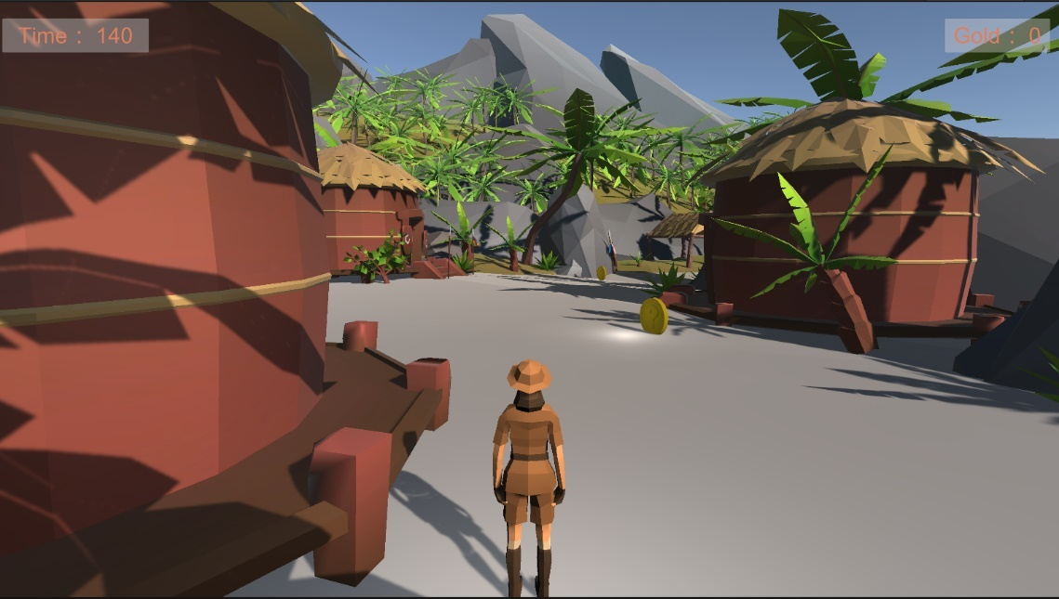**Title**: Begin Page **Frame ID**:Begin

**Dimensions:**

This scene will use the maximum

available to display in the window.

**Media Used:**

**Background music:** Of course, background music is also needed here. The background music selects mysterious and tense music, which arouses users' interest in the game. Let the user have an immersive feeling and enhance the user's user experience.

**Fonts**：Choose a more obvious color, highlight the countdown and the number of gold coins, and remind users. Choose a simple and large font so that the text stands out against the background. And a layer of "panel" is added between the background and the text to dilute the clutter of the background and highlight the text content. The font sizes are 60.

**Image**: This page uses the assets imported in the unity assets store as the background, and puts in a lot of trees, wooden houses, stones, etc. that match the theme, so as to create an overall atmosphere. In the scene, gold coins are scattered all over the place, and you need to find it yourself, although this may take some time, But that's where the fun of the game lies. The characters are also very close to the overall background, and they will not create a sense of abruptness when placed in the scene. And the objects in the scene are all added with colliders, which allows the entire scene to run normally, although some ranges are still not fine enough, I will gradually improve this in the future on the road of learning. At the same time, when collecting ten gold coins and finding a friend, a prompt window will pop up, which will prompt the user for the next action. This is also a UI design to improve the user experience.

**Buttons**: There is no button on this page, because this is a game, but you can use the keyboard and the mouse to control the characters. Keyboard controls the action of the characters, the mouse controls the field of view. There is a design button on the prompt window, but there is no design sound effect, because the entire scene has a background music, then add button Tips, the user produces auditory confusion..

**Background**: This page is based on the asset imported in the Unity Asset Store store, and puts a lot of trees, wooden houses, stones, etc. to create a whole atmosphere. At the same time, the image of the characters is also very in line with the overall atmosphere. It does not have an abrupt feeling in the scene, giving the user a good visual experience.

At the same time, put the background music, create a tension of rescue, so that users feel good user experience, as if they are the master of the game. The gold coins are scattered in the scene, of course, the gold coins are very large, and users can easily see them. The entire background allows users to feel the joy of the game.

Content: This scene is the main scene of the game. The little boy was captured by the bad guys because he stopped the bad guys from cutting down the tree. The protagonist must find ten gold coins and get the qualification to cross the bridge to rescue the boys and carry out their next environmental protection action.

**Description (purpose / objectives):**

This scene is the main scene of the game. The little boy was captured by the bad guys because he stopped the bad guys from cutting down the tree. The protagonist must find ten gold coins and get the qualification to cross the bridge to rescue the boys and carry out their next environmental protection action. The purpose of this scene is to let users participate in the game in a pleasant and experiential sense, with background music, prompt windows, etc. A good UI is designed to improve the user experience.

**Animations:**

Characters can walk, turn, control vision, etc. And the objects in the scene are all added with collision bodies, characters will not pass through stones and trees, etc., but the range of collision bodies is not accurate enough and needs to be improved. Gold can be picked up, and the countdown text and gold counts will also be improved.

**User Interactions Required:**

The countdown and the number of gold coins are set above the scene, which can remind the user well. At the same time, when collecting ten gold coins and finding a companion, a prompt window will pop up to remind the user what to do next. This is an important user interaction so that the user does not feel lost while playing the game. At the same time, there are buttons on the prompt window. These user interactions improve the user experience and allow users to increase their satisfaction with the game.

**User Feedback：**

The countdown and the number of gold coins are set above the scene, which gives the user a feedback. At the same time, when collecting ten gold coins and finding a companion, a prompt window will pop up to remind the user what to do next, which is also feedback to the user. At the same time, we asked classmates to experiment with our game, and it was generally reported that the collision body was not accurate enough.

**Navigation / Links:** The navigation bar will link to the end page and prompt window.

**Title**: End Page **Frame ID**: End 1

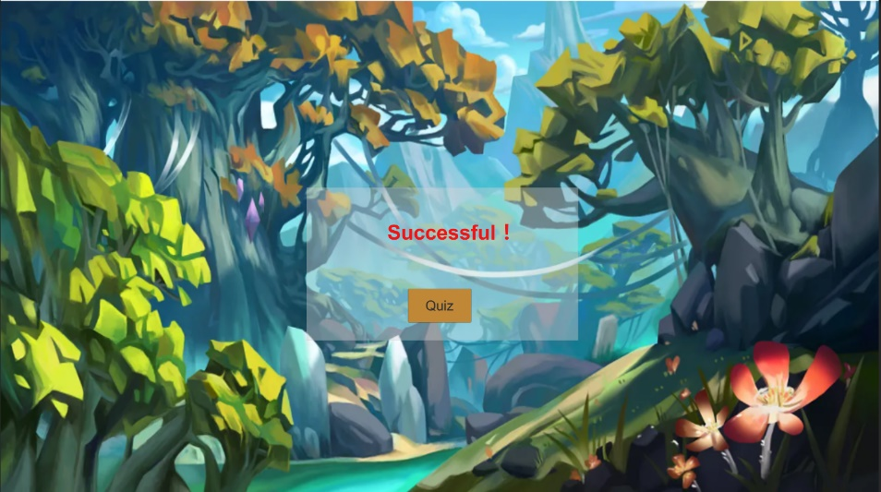**Dimensions:**

This scene will use the maximum

available to display in the window.

**Media Used:**

**Background music:** Since there are background music on the page before, and stay on this page for a short time, in order to prevent auditory confusion, no background music is added on this page.

**Onclick**： There will be a sound feedback to ensure that the buttons successfully clicks the button and improve the user experience.

**Fonts**：Choose the simpler button. Because the background is more colorful, choose a lighter font to highlight the buttons. The font sizes are 60 and 90.

**Image**: The page uses a picture as the background and adds one button on it to quiz.

And the word “Successful” tells that you are successful to rescue your company.

**Buttons**: The page provides “Quiz” button, and the text notes on the buttons are convenient for users to understand their functions (quiz the page).

**Background**: The page uses a slightly fancy image as a background to accentuate the beauty. So simple button and word are added so that when you browse the page, it does not look cluttered and brings a good user experience to the user.

Content: This page is just a "End" page to guide users.

**Description (purpose / objectives):**

This page is just a "End" page to guide users. This page accentuate the beauty. The purpose is to tell users the result. A refined ending gives the user a sense of pleasure.

**Animations:**

When the mouse is over or clicked on the button, the button will change to a different

color to enhance the user experience. And there will also be a button tone to remind

the user what to do.

**User Interactions Required:**

Users need to click the "Quiz" button to quiz the game. When the mouse is over or clicked on the button, the button will change to a different color to enhance the user experience. And add a panel to slightly isolate background from the text so that the text doesn't hide in the fancy background.

**User Feedback：**

Click the "Quiz" button to quiz the game. When the mouse is over or clicked on the button, the button will change to a different color, and there will also be a button sound to give user

feedback. At the same time, I also found my classmates to try it out, and the classmates

thought it was very nice.

**Navigation / Links:** The navigation bar can help you quiz the game.

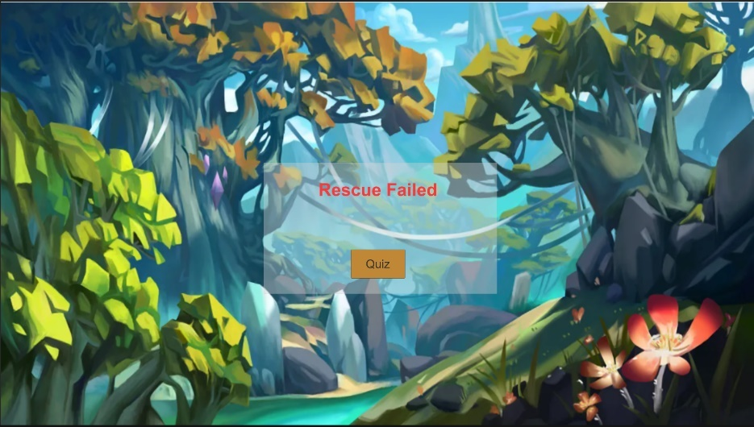**Title**: End Page **Frame ID**: End 2

**Dimensions:**

This scene will use the maximum

available to display in the window.

**Media Used:**

**Background music:** Since there are background music on the page before, and stay on this page for a short time, in order to prevent auditory confusion, no background music is added on this page.

**Onclick**： There will be a sound feedback to ensure that the buttons successfully clicks the button and improve the user experience.

**Fonts**：Choose the simpler button. Because the background is more colorful, choose a lighter font to highlight the buttons. The font sizes are 60 and 90.

**Image**: The page uses a picture as the background and adds one button on it to quiz.

And the word “Rescue Failed” tells that you are failed to rescue your company.

**Buttons**: The page provides “Quiz” button, and the text notes on the buttons are convenient for users to understand their functions (quiz the page).

**Background**: The page uses a slightly fancy image as a background to accentuate the beauty. So simple button and word are added so that when you browse the page, it does not look cluttered and brings a good user experience to the user.

Content: This page is just a "End" page to guide users.

**Description (purpose / objectives):**

This page is just a "End" page to guide users. This page accentuate the beauty. The purpose is to tell users the result. A refined ending gives the user a sense of the beginning and the end.

**Animations:**

When the mouse is over or clicked on the button, the button will change to a different

color to enhance the user experience. And there will also be a button tone to remind

the user what to do.

**User Interactions Required:**

Users need to click the "Quiz" button to quiz the game. When the mouse is over or clicked on the button, the button will change to a different color to enhance the user experience. And add a panel to slightly isolate background from the text so that the text doesn't hide in the fancy background.

**User Feedback：**

Click the "Quiz" button to quiz the game. When the mouse is over or clicked on the button, the button will change to a different color, and there will also be a button sound to give user

feedback. At the same time, I also found my classmates to try it out, and the classmates

thought it was very nice.

**Navigation / Links:** The navigation bar can help you quiz the game.

# Media

|  |  |
| --- | --- |
| Image name or description | Resource address/URL |
| Pictures | https://image.baidu.com/ |
| Background | Unity assets store |
| Volume | https://www.aigei.com/s?q=%E7%82%B9%E5%87%BB&type=sound |

Menu: Font(Arial and Anton)

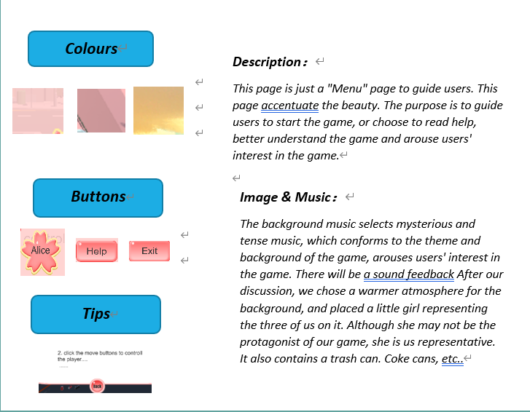

Begin：Font(Arial)

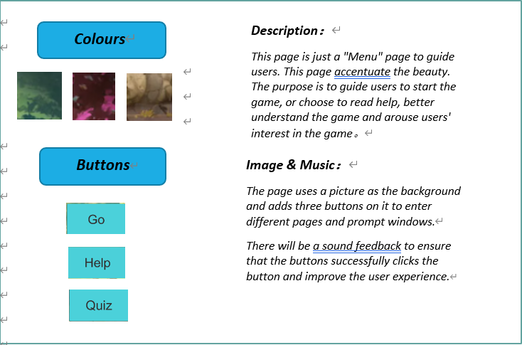

Game：Font(Arial)

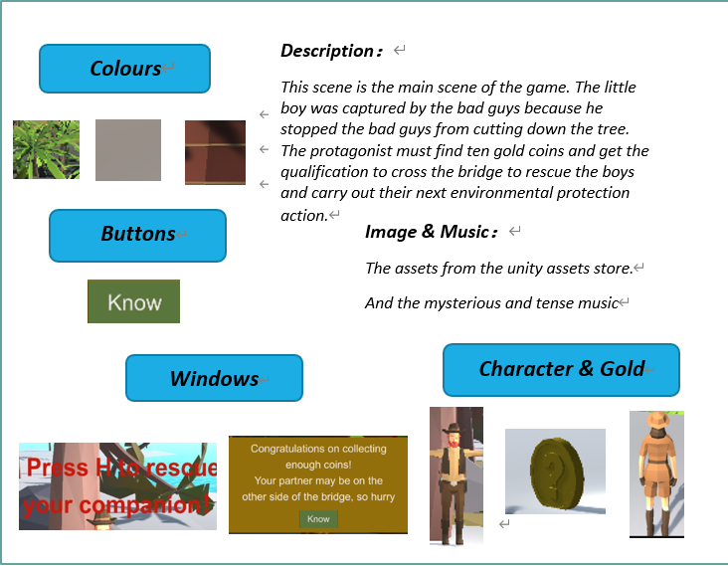

End: Font(Arial)

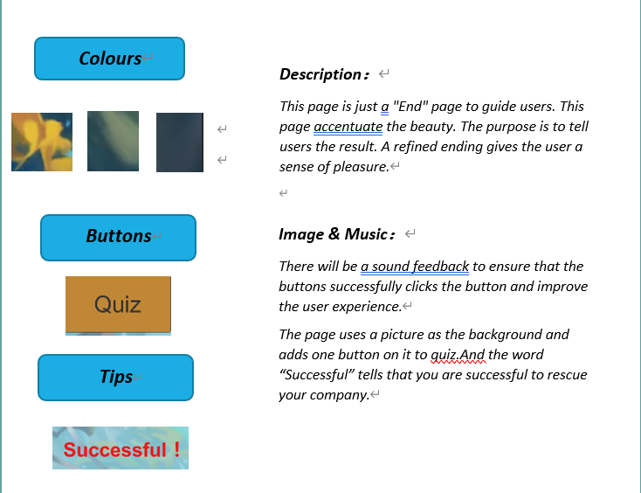

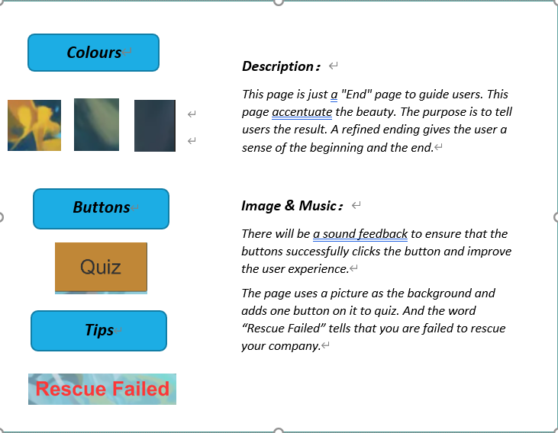

# mood board

## Menu:

### Picture:

On the picture of the menu, we took Yolanda's proposal and took the street as the background, because in terms of environmental protection, the closest thing to us is the environmental protection of the street. At the same time, the overall atmosphere of this street is more warm, which is in line with the feeling of the whole page.

And at my (Alice) suggestion to put a little girl in it, she might not be our protagonist, but she represents the three of us. We also added trash cans, Coke cans, and other assets that symbolize our themes.

Of course, we also took Jerry's advice and made the button very beautiful, using pink. Makes the entire page look very comfortable.

### Color

In terms of color, our entire menu is warmer tones, which looks more relaxing. No cool colors, because we just want to awaken people's green heart and make this game more approachable. At the same time, it brings visual comfort to users and improves user experience.

### Music

In terms of music, we unified the idea of designing the button sound and background music to be brisk, which also matches our theme background, giving people a relaxed and pleasant feeling as a whole. The background sound effect stimulates the user's interest in the game, and also brings an auditory impact to the user.

Button sounds act as feedback so users know what they've done. Also I (Alice) reminded everyone to cancel the "Play On Awake" button sound. This kind of feedback keeps the user fresh and continues, improving the user experience and at the same time being a good user interaction.

### Button

In the assignment 2, our button is very single, and the layout is not very reasonable. This time we beautify the shape and color of our button, and put it in a place that doesn't violate the whole layout. At the same time, a button sound is added to the button. As well as a color change when the mouse is rolled over and pressed. We follow the UX design principles to give users a sense of satisfaction both visually and audibly, and improve the user experience.

### Font

Our fonts are very atmospheric, and the font sizes used are mostly 20 and 60. On the title, our font size is very large, after all, the title should attract the attention of readers. On the button we have a slightly smaller font to maintain a sense of harmony.

Our fonts are simple, without any bells and whistles, so that users can read the text smoothly without creating visual clutter.

### UI

On the menu, we took a prompt window to play the Help method (Yolanda's idea) such as both interesting or another new page, I think this is a good idea to enhance the user experience. At the same time, we also provide a color change and button tone for the button, so you can take care of the user's feelings, let them not feel confused when the game, will not doubt it to click on the button.

At the same time, Help is equipped so that users can understand our content reasonably.

## My Scene

### Picture:

In my scene, the overall ambience of my pictures fits my "trees-friendly" theme with lots of trees, stones, and wooden houses. Similarly, the external image of the characters is also in line with the overall environment. To be honest, there are some similarities with the backs of the protagonists of my other team members. Meanwhile, my game pickups are gold coins,

You must save ten gold coins. This is not the same as the items of my other two friends. In fact, at the beginning, I also used milk cartons, Coke cans, etc., but I found in the process of modification that this does not match my theme. After all, my The theme is "Tree Protection", not "Trash Cleaning".

### Color

In terms of color, in my scene, the colors are relatively simple, green, gray, brown, etc. The whole style is cool and concise, so that users will not feel the clutter of the page when playing the game. Bring a good user experience to users. Bring visual "coolness" to users.

### Music

### In terms of music, I adopted a mysterious and tense music, creating a "rescue" feeling, so that users have a feeling of personal experience at the scene. At the same time, this kind of music can mobilize the excitement of the user, so they keep the game freshness. At the same time, the button will give the user a feedback to the user, so that they will not discomfort because they don't know if they click. Optimize the user experience.

### Button

In A2, I received feedback that the buttons were slightly smaller, so this time I purposely made the buttons larger to enhance the user experience. At the same time, on some pages, my buttons will change color or have button beeps due to mouse over or click. And optimized the button colors to make them stand apart from my background image as much as possible. Let beauty and clarity coexist. In this way, the user's visual experience can be increased, and the user can carry out their operations with a clear purpose.

### Font

My fonts are very bold, mostly 60 and 90 font sizes. Larger fonts allow users to find buttons at a glance and maintain a sense of harmony.

Our fonts are clean without any bells and whistles, so that users can read the text smoothly without visual clutter, and use colors to differentiate them from background images.

### UI

In my scene, I also used the function of the prompt window, which greatly saved the page. After all, I made two prompt windows and text similar to the prompt window. This can reduce the burden of the entire game. And when the user reaches a certain stage, it can give users some reasonable prompts to let them take the next step. At the same time, I also set the color change and beep sound for the button.

These UI designs are very necessary, they greatly improve the user experience and improve the user's goodwill.

# Group character assignment

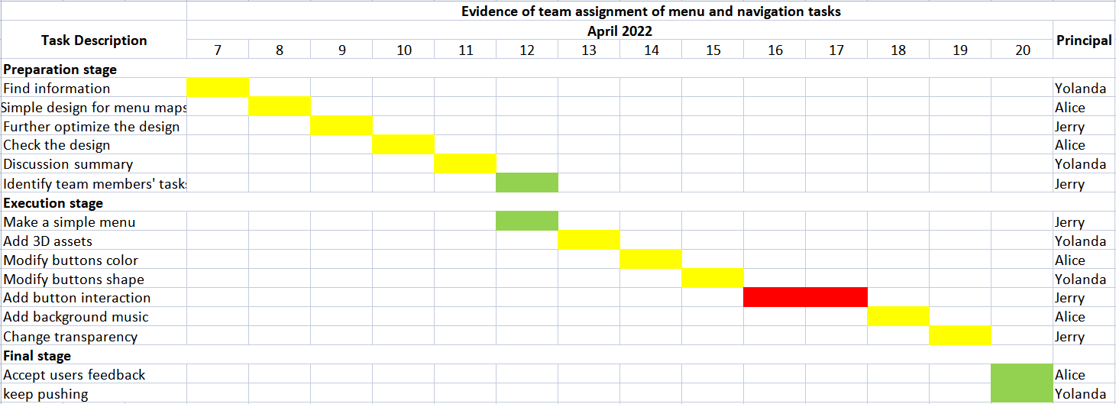

# UI discussion notes

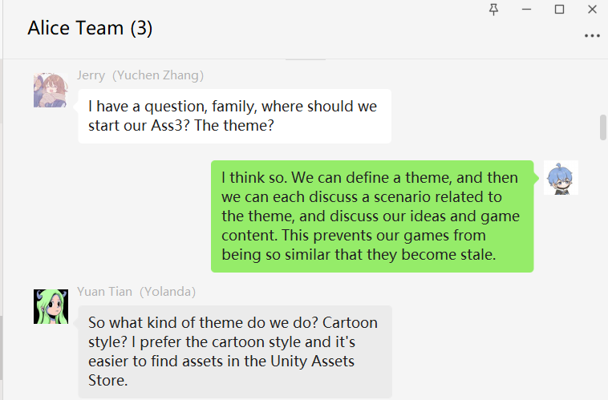

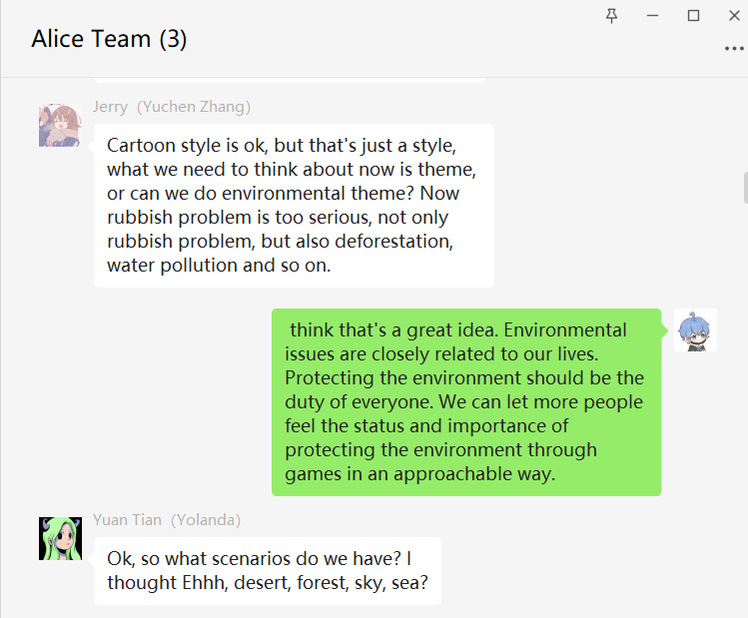

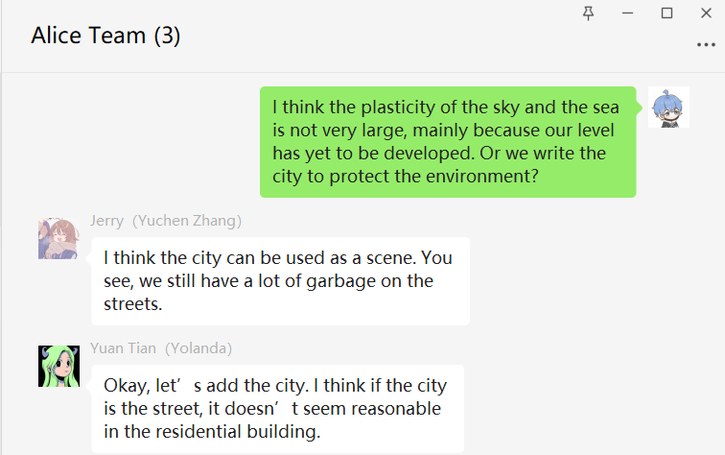

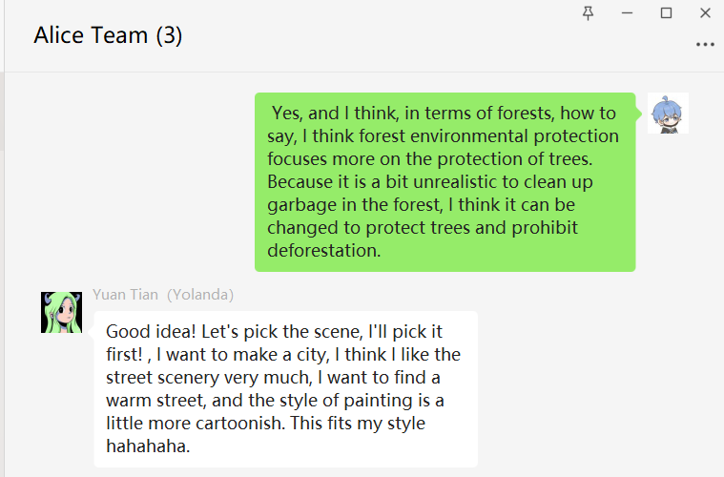

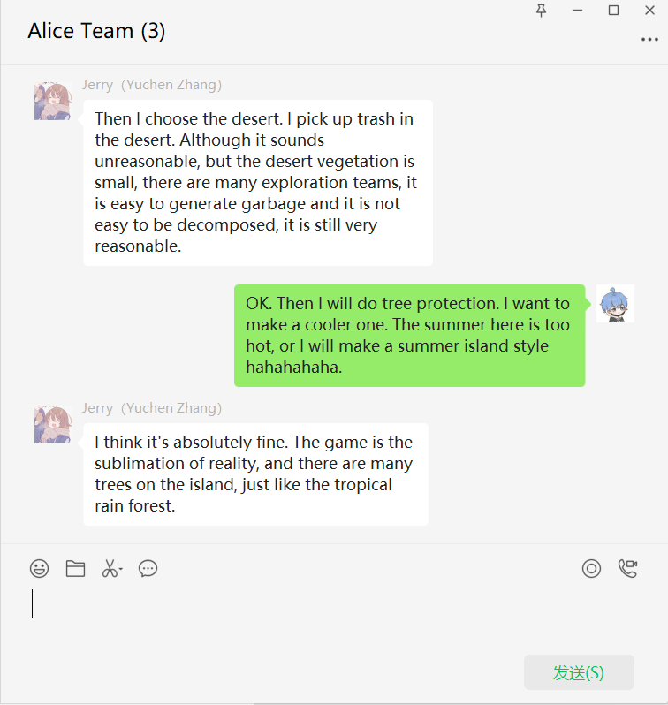

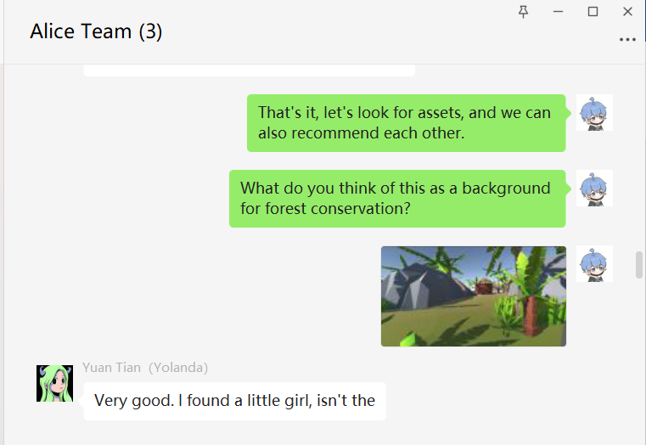

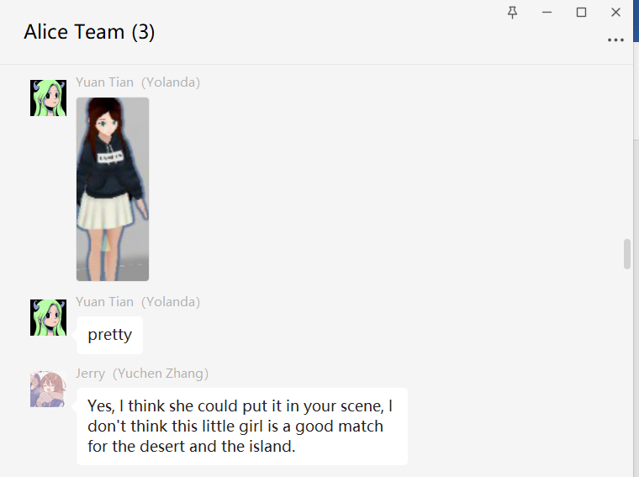

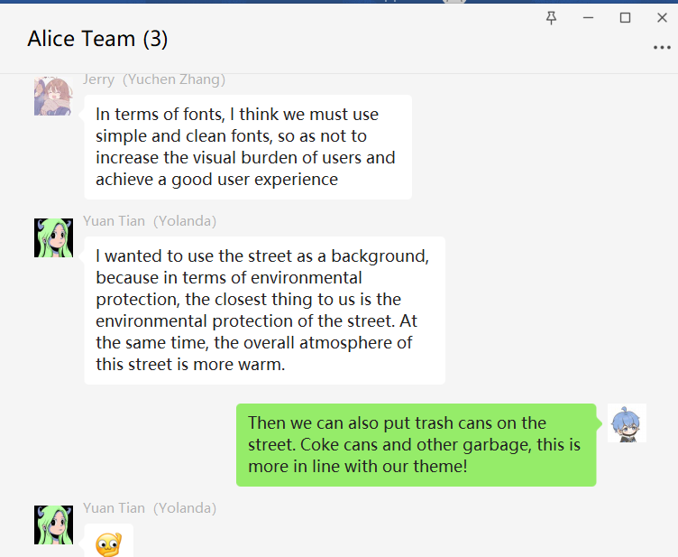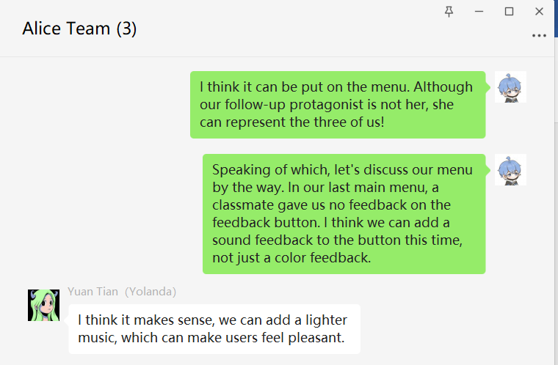

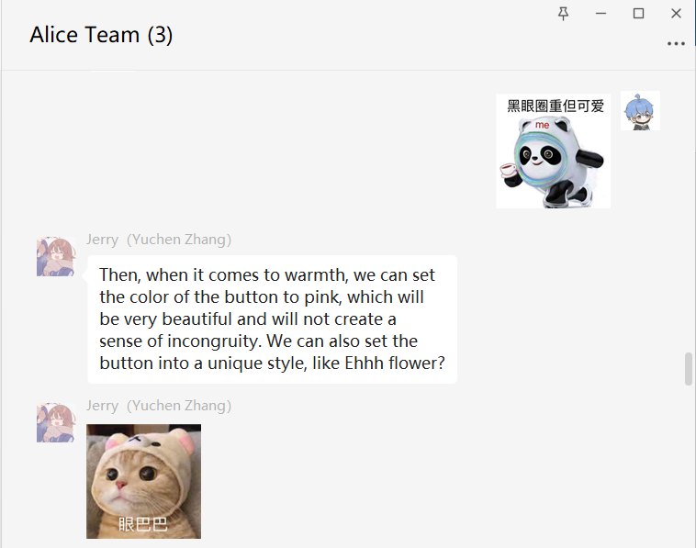 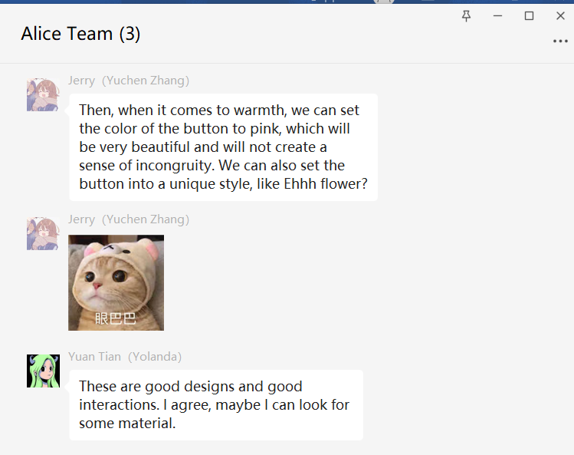

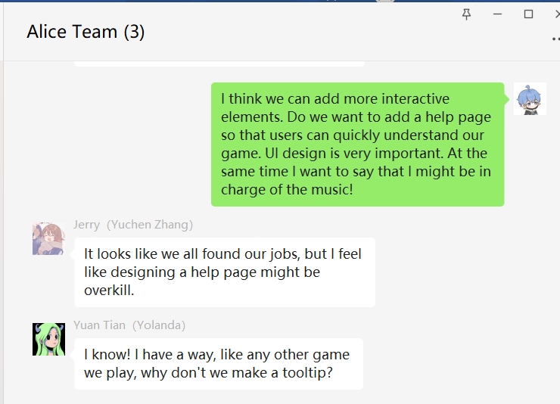

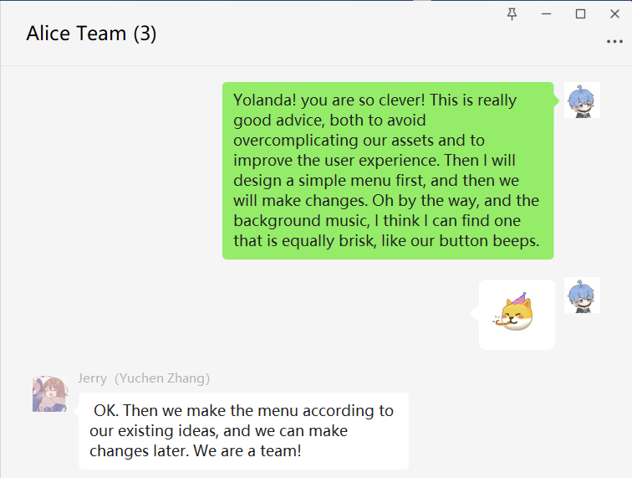

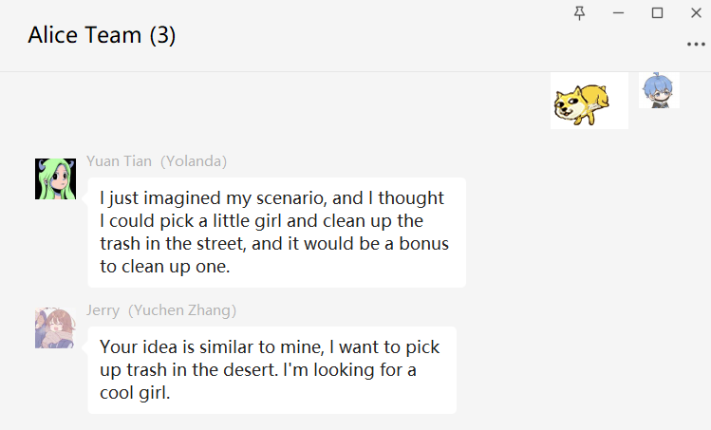

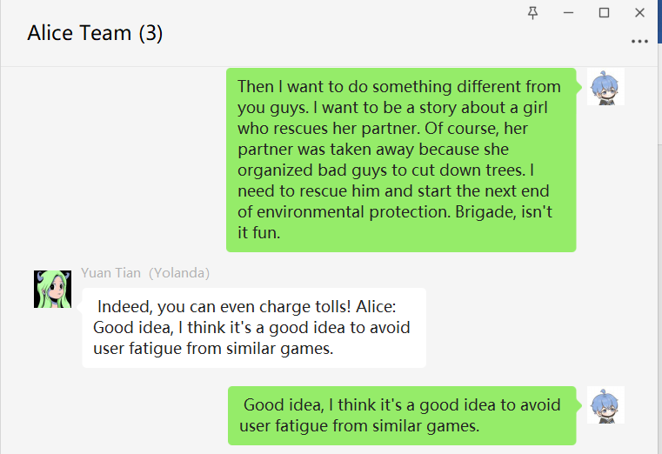

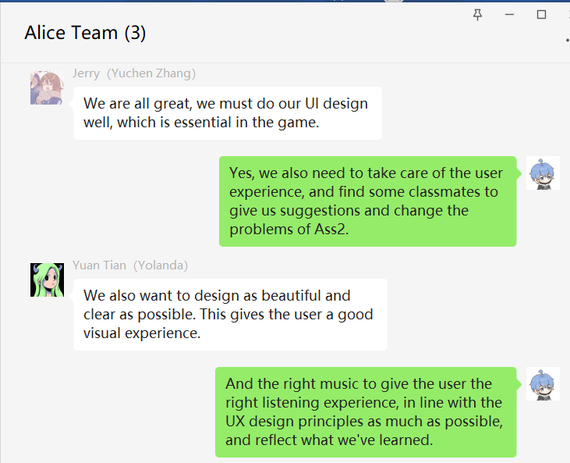

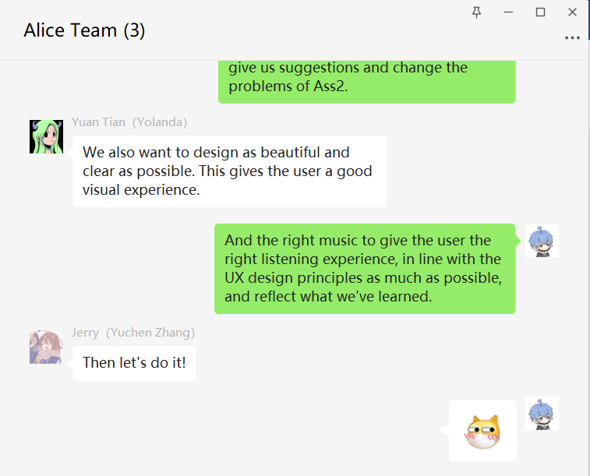

: Yuchen Zhang(Jerry)

: Yuan Tian(Yolanda)

:Jiawen Bu(Alice)

# GitHub modification record

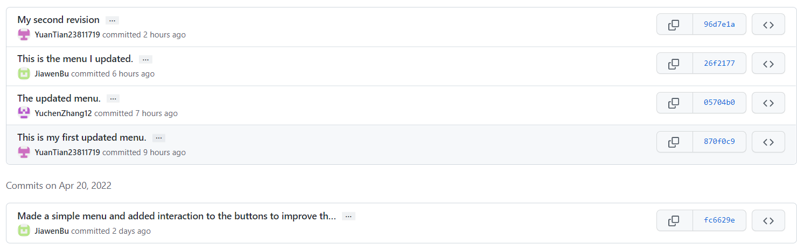

# ASS2_Link and comment

https://jiawen-bu.itch.io/jiawen-bu-ass2

